

Getting Started with Zoom Phone

(Click on the black triangle to the left to expand to instructions)

Contents

# Contents

Initial Setup 1

Phone Settings 1

Contacts 1

Phone Calls 1

In-Call Controls 1

Voicemail 1

Call History and Recordings 1

Desk Phones 1

Additional Features 1

Need help? 1

# Initial Setup

1. If your Zoom Phone admin assigned you a Zoom Phone license, you will get an email notification with a link to set up Zoom Phone.

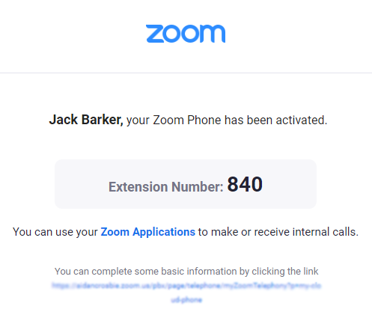

1. Click the link at the bottom of the email notification. If you didn't get an email, sign in to the Zoom web portal and click [**Phone**](https://zoom.us/pbx/page/telephone/myZoomTelephony?p=my-cloud-phone).
2. Enter the required information to set up Zoom Phone:  
   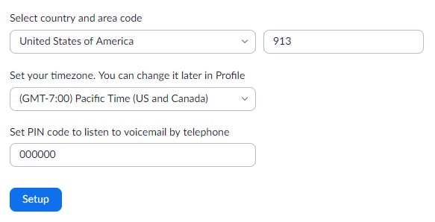
   * **Country and area code**: The area code is used when you dial local numbers.
   * **Timezone**: Make sure you set the correct timezone. It will affect several Zoom Phone features including your business/closed/holiday hours and desk phones assigned by your admin.
   * **PIN**: Enter a voicemail PIN used to check your voicemail on desk phones assigned by your admin. You will not need the PIN to check voicemail using the Zoom desktop, mobile app, or web portal.
3. Click **Setup**.

# Phone Settings

After the initial setup, you should adjust your [Zoom Phone settings](https://support.zoom.us/hc/en-us/articles/360021325712) in the web portal.

1. Sign in to the Zoom web portal.
2. Click **Phone**, then click the [**Settings**](https://zoom.us/pbx/page/telephone/myZoomTelephony#/my-cloud-phone/settings) tab. Here are a few essential settings you may want to change:

* **Emergency Address**: Displays the address provided to first responders when dialing an emergency number. Make sure this address is correct.
* **Business/Closed/Holiday Hours**: Change the times when you can answer calls.
* **Voicemail Greeting**: Audio that plays before Zoom Phone routes calls to your voicemail. You can customize this by [recording audio directly in the web portal or uploading an audio file](https://support.zoom.us/hc/en-us/articles/360028212652).

# Contacts

By default, you can call the contacts directory in the Zoom desktop client or mobile app to call people in the same organization. Follow these articles to add contacts from third-party services:

* **Zoom Desktop client**: [Sync your contacts with Google, Office 365, or Exchange](https://support.zoom.us/hc/en-us/articles/360000488243). After syncing your contacts, you can add synced contacts using your [call history](https://support.zoom.us/hc/en-us/articles/360021336671) or [voicemail](https://support.zoom.us/hc/en-us/articles/360021400211).
* **Zoom mobile app**: [View your phone's contacts](https://support.zoom.us/hc/en-us/articles/360032308211) in the Zoom Phone mobile app.

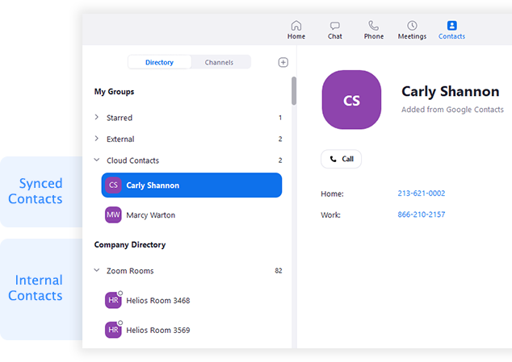

# Phone Calls

After setup, you can start [making and receiving calls using Zoom Phone](https://support.zoom.us/hc/en-us/articles/360021087192). Make calls using the dial pad or search through your internal, external or synced contacts. For incoming calls, you can decline a call to route it to your voicemail.

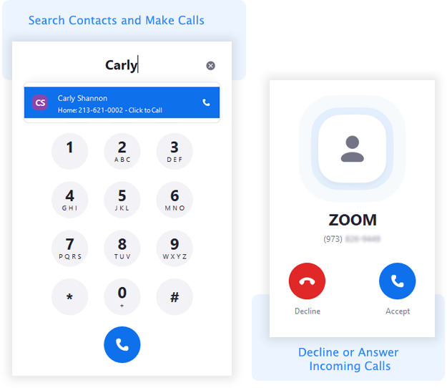

# In-Call Controls

While in a call, you can:

* Access [in-call controls](https://support.zoom.us/hc/en-us/articles/360036228011) like hold, record, and [transfer](https://support.zoom.us/hc/en-us/articles/360028786771).
* [Start a Zoom meeting](https://support.zoom.us/hc/en-us/articles/360026902831) with the other person on the call.
* Use [call flip](https://support.zoom.us/hc/en-us/articles/360034613311) to switch the device you are using for the call.

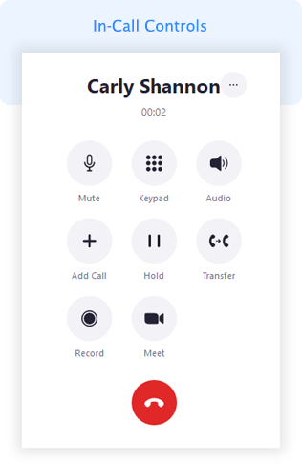

# Voicemail

Zoom Phone forwards all unanswered and declined inbound calls to your voicemail. You can use the Zoom desktop client, mobile app, or web portal to [play and manage your voicemail messages](https://support.zoom.us/hc/en-us/articles/360021400211).

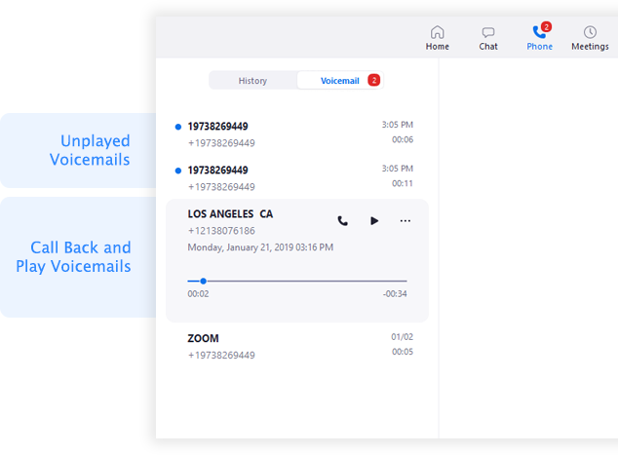

# Call History and Recordings

After making, receiving, or recording calls, you can [check your call history and recordings](https://support.zoom.us/hc/en-us/articles/360021336671) on the Zoom desktop client, mobile app, or web portal.

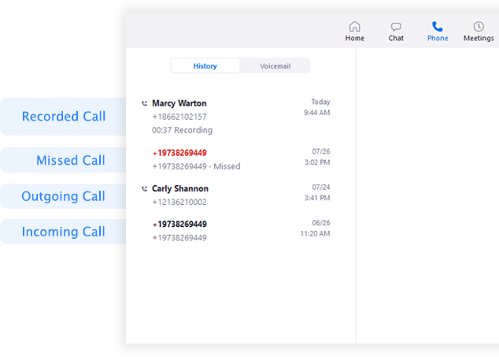

# Desk Phones

If your Zoom Phone admin set up a desk phone for you, you can use it to make and receive calls and check voicemail. See our quick start guide for [Polycom VVX series](https://support.zoom.us/hc/en-us/articles/360038946292) and [Yealink T4/T5 series](https://support.zoom.us/hc/en-us/articles/360033475992) phones. Desk phones don't support all [Zoom Phone features](https://support.zoom.us/hc/en-us/articles/360029698771).

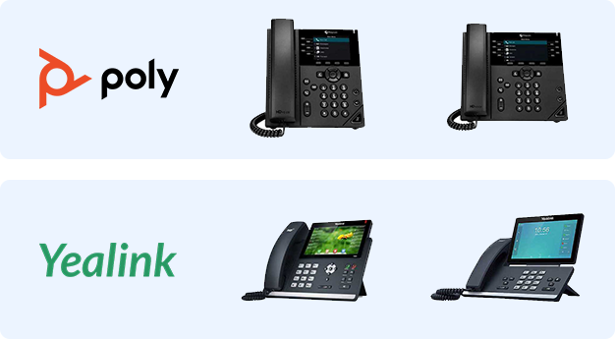

# Additional Features

Once you are familiar with Zoom Phone, use these features to further enhance your experience:

* [**Zoom Desktop Client and Mobile App settings**](https://support.zoom.us/hc/en-us/articles/360030985091): View your Zoom Phone information including your company number, extension number, and direct phone numbers. You can also change settings for inbound call notifications.
* [**Blocked list**](https://support.zoom.us/hc/en-us/articles/360021325712#blocked-list)**:** Change your settings to block specific phone numbers or prefixes from calling you.
* [**Call delegation**](https://support.zoom.us/hc/en-us/articles/360032881731): Assign another phone user to make and receive calls on your behalf.
* [Shared voicemail inbox](https://support.zoom.us/hc/en-us/articles/360033863991): Share you voicemails with another phone user in the same organization.
* [**Click to dial**](https://support.zoom.us/hc/en-us/articles/360027633731): Change your settings on Mac or Windows so you can click on a phone number to dial it in Zoom Phone.

# Need help?

Open a ticket with the helpdesk:

**Support Phone**:   (206) SEO-HELP (206-736-4357)

**Support Email**:     [support.request@seo-usa.org](mailto:support.request@seo-usa.org)