Technology

How to Reset your SEO Password

# For employees with SEO-issued laptops (full-time employees usually)

1. Click on the little **up arrow on the bottom right of your screen**, then click the **Cisco AnyConnect Icon**.

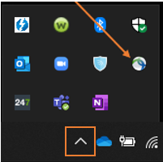

1. Type in **vpn.seo-usa.org** as the VPN address, then click **Connect**.

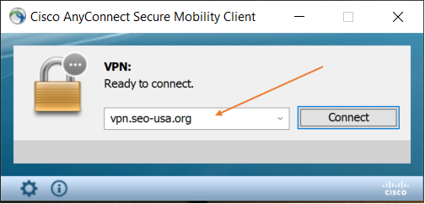

1. Type in your **username** (the first part of your email address before the ‘@’ symbol) and **computer password**, then click **OK**.

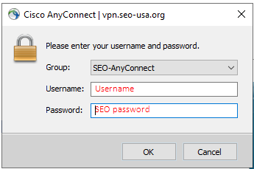

1. Once connected to the VPN, press and hold **Ctrl** + **Alt** + **Del** on your keyboard to get to the ‘**Change a password**’ screen, enter the password information required and save.

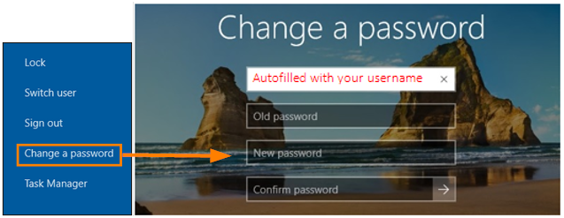

# For part-time staff who do not have an SEO-issued laptop

Navigate to <https://passwordreset.microsoftonline.com/>, complete the instructions.

# Need help?

Open a ticket with the helpdesk:

**Support Phone**:   (206) SEO-HELP (206-736-4357)

**Support Email**:     [support.request@seo-usa.org](mailto:support.request@seo-usa.org)