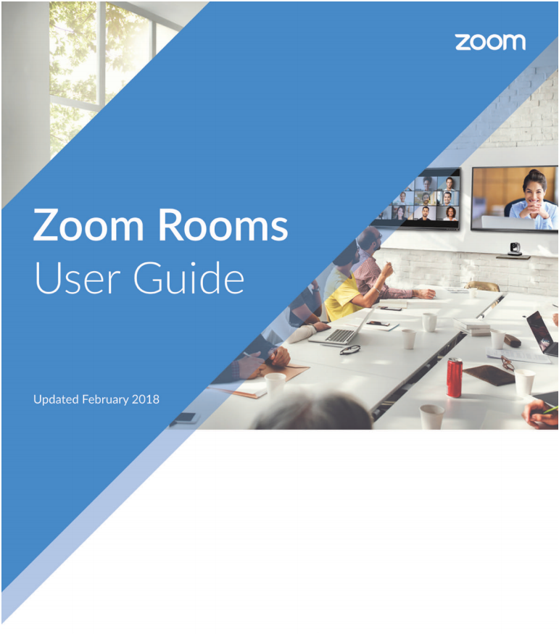

**Polycom Camera**

support.zoom.us

Contents

ROOM 6D 3

Starting an instant meeting 3

Manage Participants 5

Security 6

Share content or camera 7

Joining a meeting 8

Make a phone call 9

Present with your computer, tablet, or smartphone 10

Camera Control 13

ROOM 5A 14

Home screen 14

Contacts 15

Phone 15

New meeting 16

Manage Participants 17

# ROOM 6D

Located on the 6th floor of the NYC office.

## Starting an instant meeting

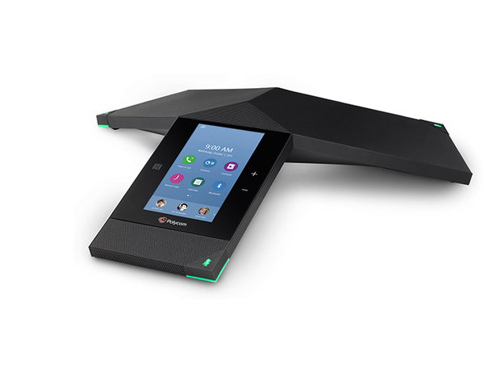Find the Polycom speaker:

|  |  |
| --- | --- |
| Tap the **Meet Now** icon to go to Figure 2,  where you can select a contact or Zoom Room to connect with. | |
| Figure 1 | Figure 2 |

* Select the contact or Zoom Room to connect to or call.
* Selecting a contact will bring you to the Starting meeting… prompt to let you know the connection is about to be established:

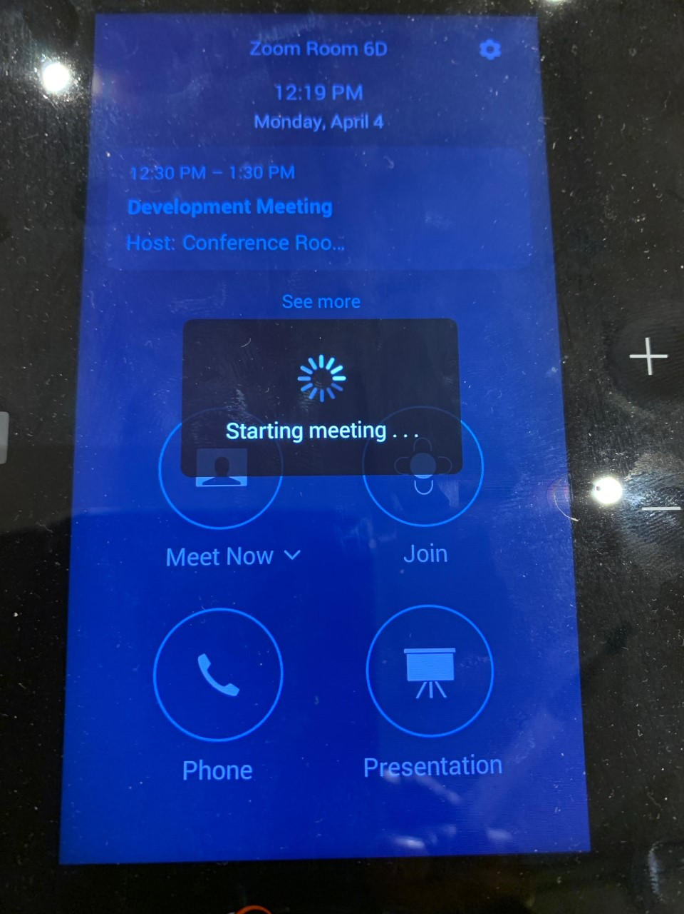

Figure 3

|  |  |  |  |
| --- | --- | --- | --- |
| * When the connection is established with the contact, you can do the following from the screen, see *Figure 4*:     Figure 4 |  | * The **More** button will take you to *Figure 5*   where you will see the following options:    *Currently, the Polycom device in Room 6D does not have keypad accommodation to its chat.  Figure 5 | |
| * + - Tap the **Mute** button to mute participants’ voices.   + Tap **Stop Video** button to close video sharing.   + Tap **Share Content or Camera** to share your screen.   + Use **Camera Control** to rotate, zoom out or zoom in.   + Tap **Leave** to leave or end the meeting. | | | * **Manage Participants**: mute/unmute, invite/remove, etc. * **Change View:** change how you view the participants; Gallery view, Host/Speaker View (see only host), Content Only (Zoom screen content). * **Start Recording**: records the meeting. * **\*Chat:** chat with participants (this only works if you have a desktop or laptop connected to your Polycom device). |

**Security**: lock the meeting, enable waiting rooms, enable Share Screen, etc. – see *Figure 6*:

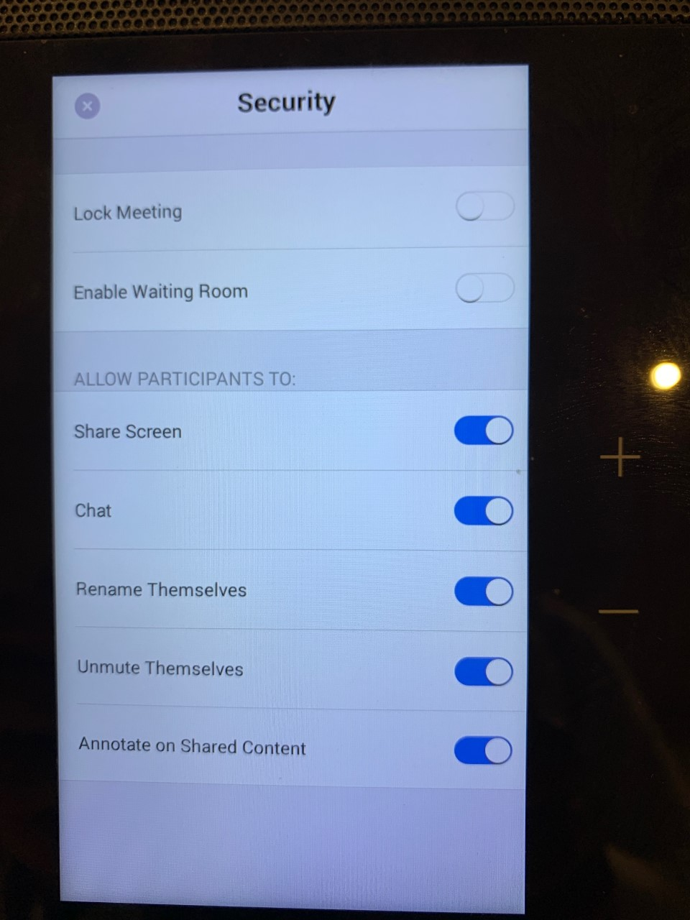

Figure 6

**Share content or camera**

When selecting **Share Content or Camera** from the menu on *Figure 7*, the following screens come up; choose to share your content with the desktop (see *Figure 8*) or iPhone/iPad (see *Figure 9*):

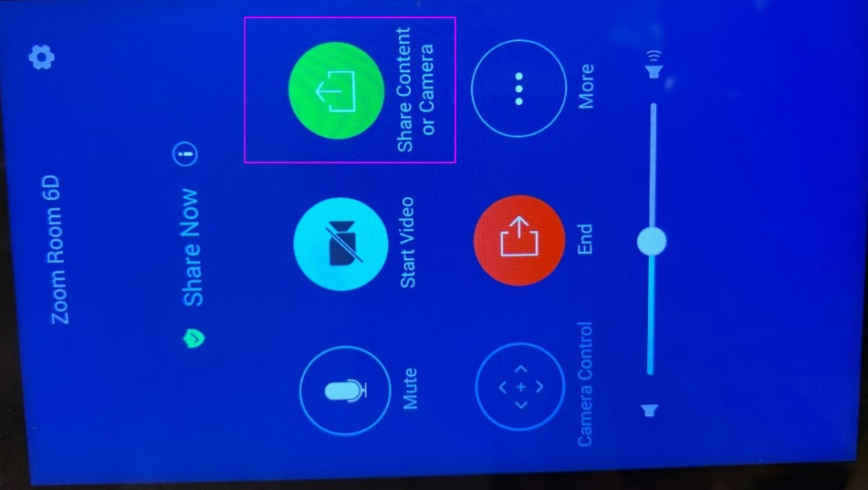

|  |
| --- |
| Sharing content to your  **iPhone/iPad**: |
| Figure 9 |

|  |
| --- |
| Sharing content to your **Desktop**: |
| Figure 8 |

Figure 7

## Joining a meeting

|  |  |
| --- | --- |
| Tap the **Join** icon to go to the screens in *Figures 10* and *11*, enter your **Meeting ID** or **Personal Link Name** to join a meeting: | |
| Figure 10 | Figure 11 |
|  |  |

## Make a phone call

To make a call from the Zoom Room to a contact’s phone number or another Zoom Room number, tap the **Phone** icon, see *Figure 12*:

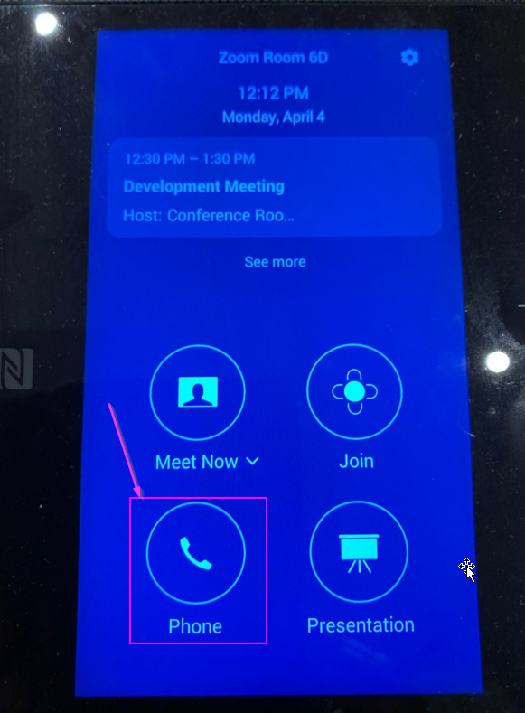

Figure 12

## Present with your computer, tablet, or smartphone

Tap the **Presentation** icon below in *Figure 13* to present content from your laptop, tablet, or smartphone. You can use the [Zoom app](https://seousa.zoom.us/download#client_4meeting) or navigate to the [online portal](https://zoom.us/share) in a web browser to present content without the Zoom app from any internet enabled device.

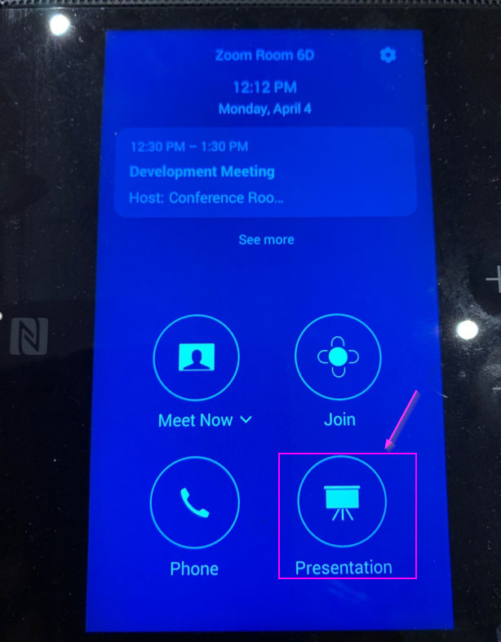

Figure 13

When the **Presentation** screen opens on the Polycom – see *Figure 14*, select the device you want to present from:

* **Desktop:** choose to present with the Zoom App or navigate to the [online portal](https://zoom.us/share) in a web browser to present content using the following information:

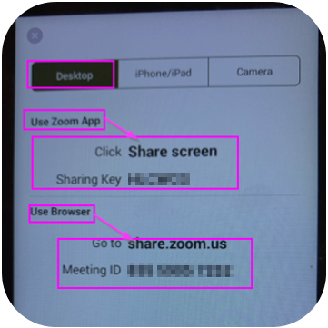

Figure 14

* **iPad/iPhone/Android device**: using the **Zoom App**, go to your **Home** on the Zoom app and click on the **Share Screen** icon:

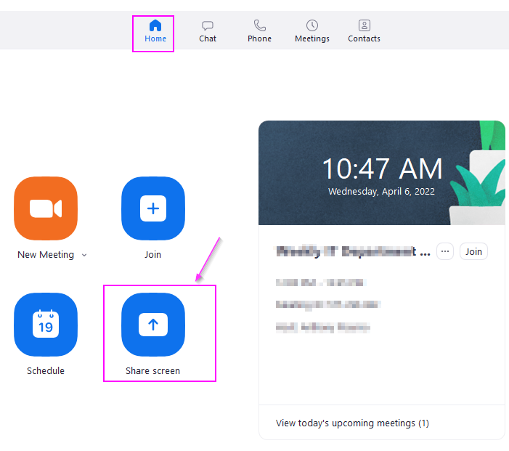

* If you do not have the [Zoom app](https://seousa.zoom.us/download#client_4meeting) installed you can still share using a **web browser**: navigate to **share.zoom.us** then enter the unique **Meeting ID** providedon the Polycom display, see *Figure 14:*

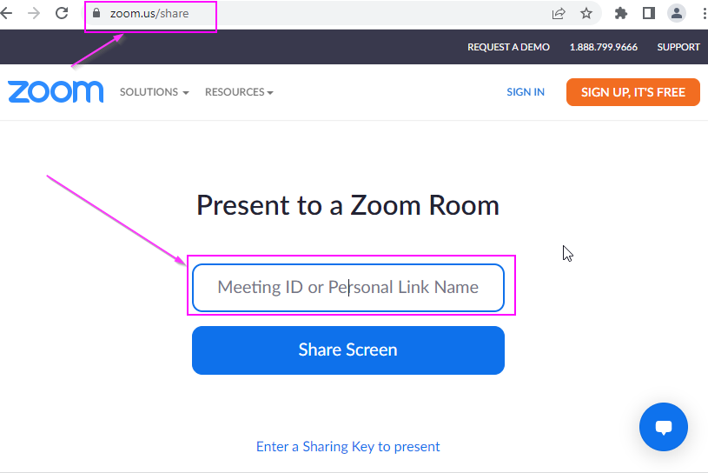

## Camera Control

Using the camera to present with **Camera Control** (notice the Camera model – Polycom EagleEye IV USB is selected):

|  |  |
| --- | --- |
|  |  |

# ROOM 5A

Located on the 5th floor of the NYC office.

The Zoom Meeting controls in Room 5A will be like in 6A since they both use Zoom Rooms.

## Home screen

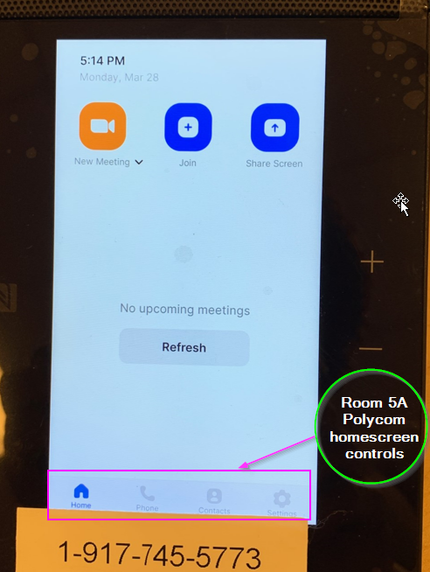

|  |  |
| --- | --- |
| **Contacts** screen: | **Phone** screen: |

|  |  |
| --- | --- |
| **New meeting** screen: | If you select the **More** button, you get the following expanded options: |
|  |  |

### **Manage Participants**

To invite participants into the meeting, click on the **Manage Participants** button and you get the following screen from which you can invite people into the meeting:

