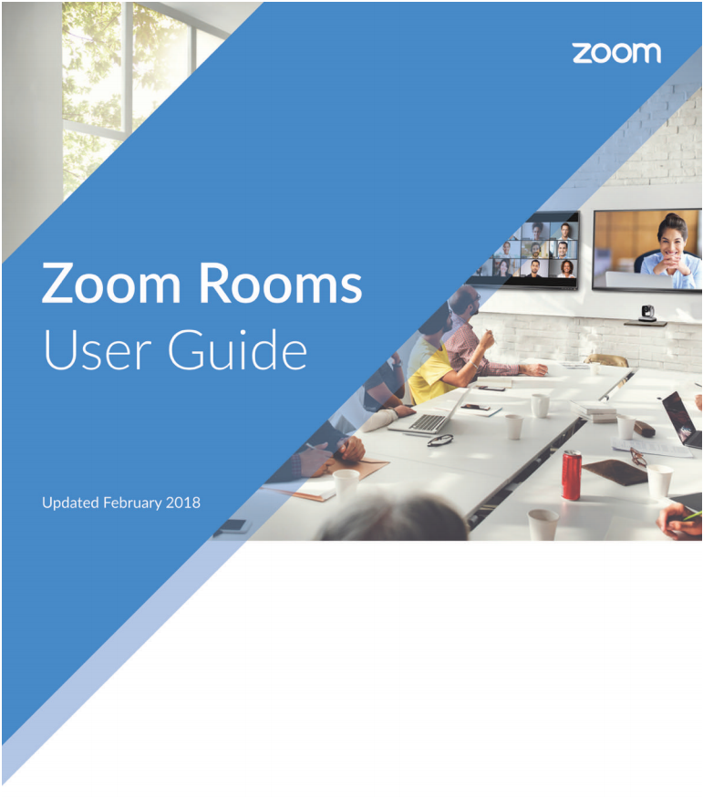

**Logitech Camera**

support.zoom.us

Contents

Start a Scheduled Meeting 3

Dial Out 3

Meet Now: Invite Others 4

Invite by Contacts 5

Invite by Email 5

Invite by Phone 5

Presentation 6

Meet Now: Share Screen 6

Manage Participants as Host 7

Share Your Screen Wirelessly without the Zoom App 8

Share Your Screen Wirelessly using the Zoom App 9

# Start a Scheduled Meeting

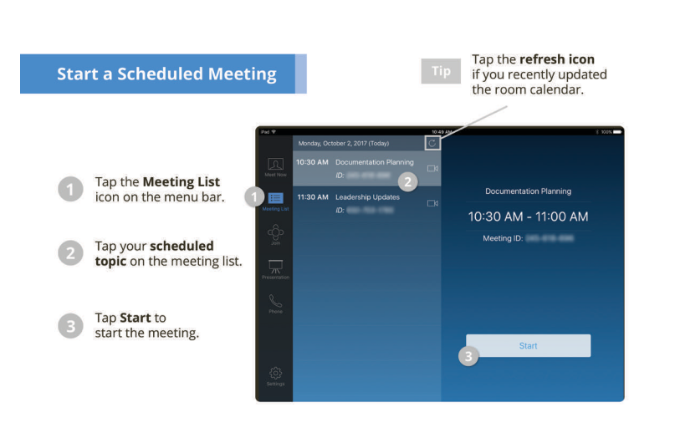

# Dial Out

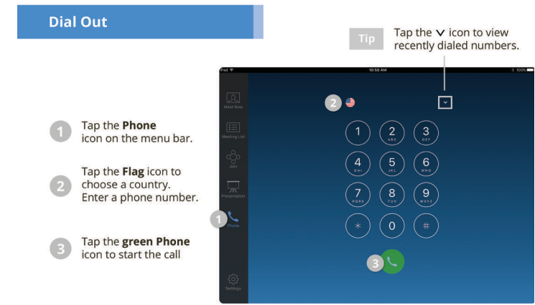

Dial **1** + **areaCode** + **number**.

# Meet Now: Invite Others

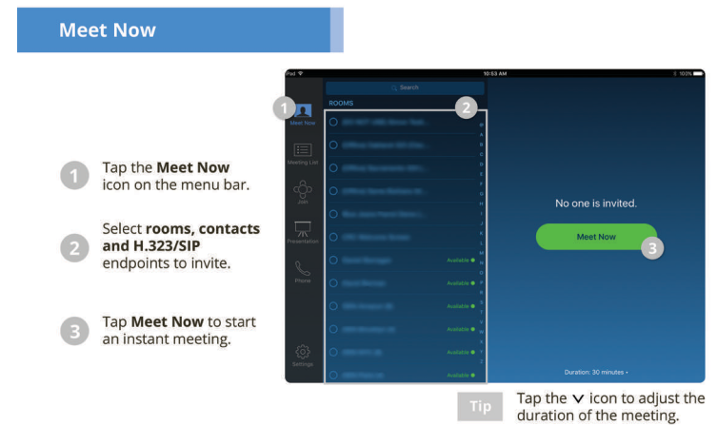







## Invite by Contacts

## Invite by Email

## Invite by Phone

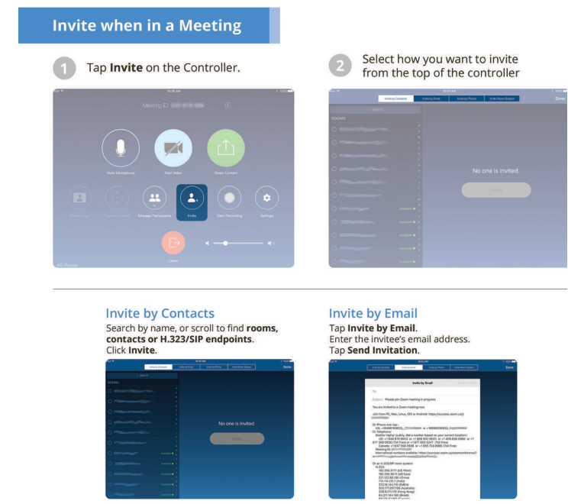

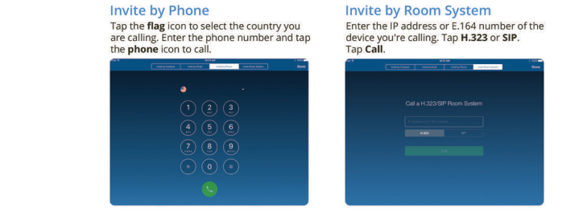

# Presentation

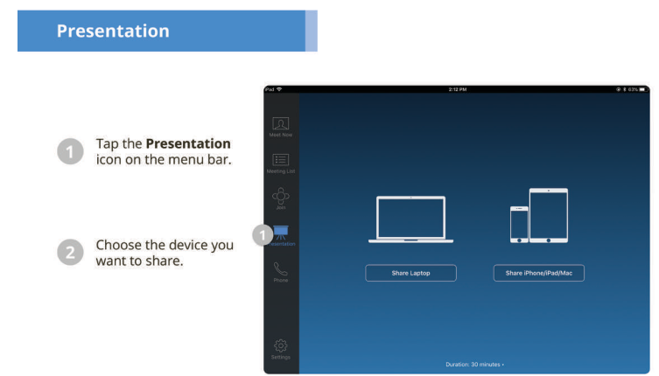

# Meet Now: Share Screen

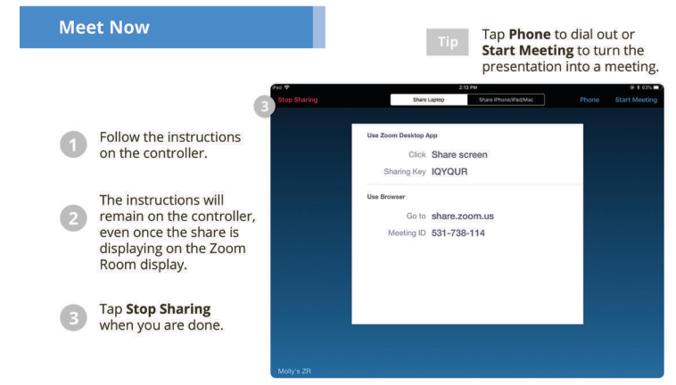

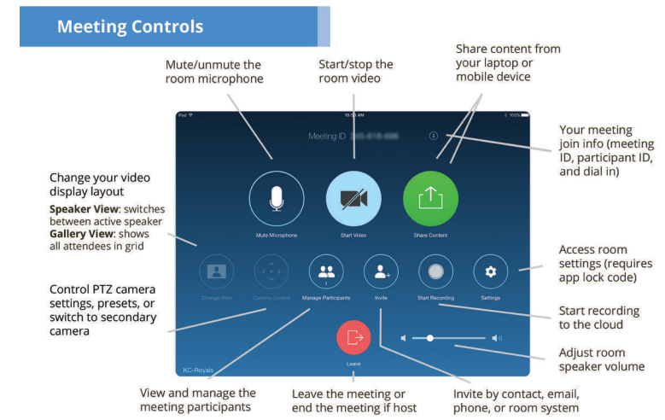

# Manage Participants as Host

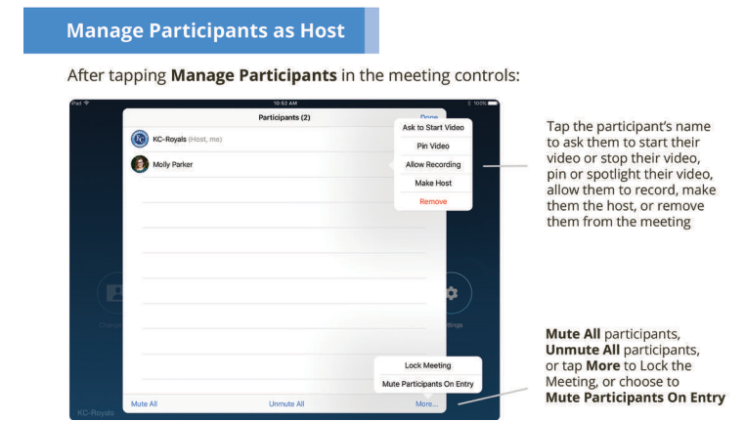

# Share Your Screen Wirelessly without the Zoom App

* In any browser go to **share.zoom.us**.
* Enter the unique **Meeting ID**, this can be found in the Zoom meeting link (see highlighted numbers) or by pressing the **Presentation** icon on the Polycom and looking for the **Sharing Key** that appears with the **Meeting ID**:

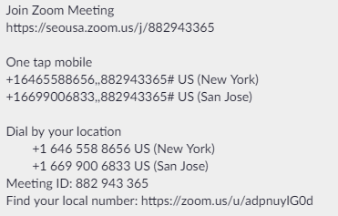

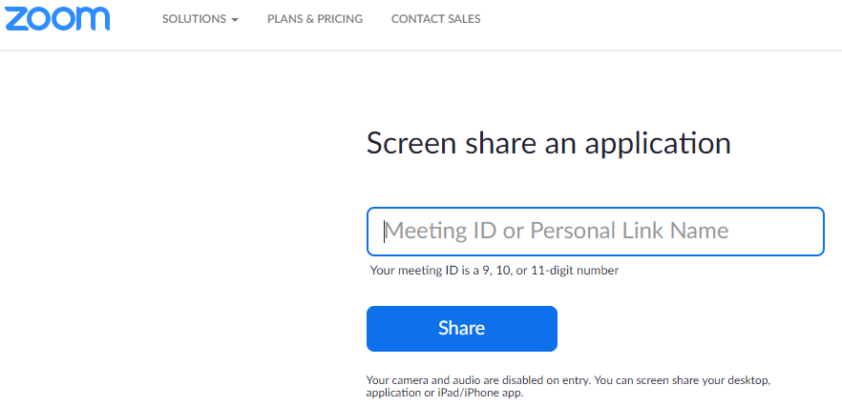

* Click **Share**, run Zoom applet that is downloaded (you may have to go to the **Downloads** folder and right-click on the Zoom applet file and select **Run as administrator**), then select the **Screen** option to share:

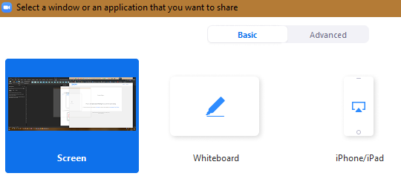

# Share Your Screen Wirelessly using the Zoom App

* For even faster sharing while in a Zoom Room, install the apps from **Zoom.us**.
* Scroll to the bottom of the website to find **Download**, then run and install the appropriate app(s):

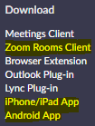

For Zoom app installation on PC.

* Once the app is installed, sign into your Zoom account:

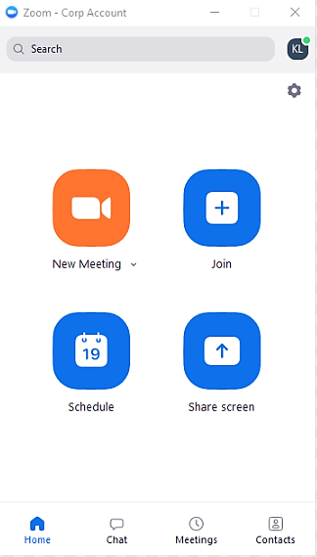

Clicking **Join** will prompt you to enter the **Meeting ID** of the meeting you want to join and share to.

Clicking **Share screen** will display the content of your choosing from your PC, mobile phone, or tablet.